Lab Assignment-2
School of Engineering and Technology
Course Name & Code: Operating System Lab ENCA252


BCA(AI & DS)-B

(2025–2026)

Prepared by:- Submitted to:-
Schin Dr.Jyoti Yadav
2401201001

IMPLEMENTATION OF BANKER’S ALGORITHM FOR DEADLOCK AVOIDANCE
Introduction:-
CPU Scheduling is an important function of an operating system that decides the order in which processes are executed by the CPU. It helps in efficient utilization of resources and improves overall system performance.
In this assignment, two scheduling algorithms, First Come First Serve (FCFS) and Shortest Job First (SJF), are implemented using Python. FCFS executes processes in the order of arrival, while SJF selects the process with the smallest burst time to reduce waiting time.
The performance of these algorithms is evaluated using parameters such as Completion Time (CT), Turnaround Time (TAT), and Waiting Time (WT). Gantt charts are also used to represent the execution sequence of processes.

Objectives:-
- To understand deadlock avoidance
- To implement Banker’s Algorithm
- To determine safe sequence
- To analyze system safety

Tools Used:-
- Python 3
- Ubuntu Linux

Task 1: System Input and Data Representation
In this task, the basic system data is provided as input. This includes:
- Number of processes
- Number of resource types
- Allocation matrix
- Maximum matrix
- Available resources
The Allocation matrix shows the number of resources currently allocated to each process.
The Maximum matrix represents the maximum demand of each process.

Task 1 Code:
class Banker:
def __init__(self, p, r):
self.p = p # number of processes
self.r = r # number of resources
self.allocation = []
self.max = []
self.available = []
def input_data(self):
print("\n--- Enter Allocation Matrix ---")
for i in range(self.p):
row = list(map(int, input(f"P{i}: ").split()))
self.allocation.append(row)
print("\n--- Enter Maximum Matrix ---")
for i in range(self.p):
row = list(map(int, input(f"P{i}: ").split()))
self.max.append(row)
print("\n--- Enter Available Resources ---")
self.available = list(map(int, input().split()))
Task 2: Need Matrix Calculation
In this task, the Need matrix is calculated using the formula:
Need = Max − Allocation
The Need matrix indicates the remaining resources required by each process to complete its execution.

Task 2 Code:-
def calculate_need(self):
self.need = []
for i in range(self.p):
row = []
for j in range(self.r):
row.append(self.max[i][j] - self.allocation[i][j])
self.need.append(row)

def display_need(self):
print("\n--- Need Matrix ---")
for i in range(self.p):
print(f"P{i}: {self.need[i]}")
Task 3: Banker’s Safety Algorithm
This task checks whether the system is in a safe state or not.
The algorithm works as follows:
- Initialize available resources as the working variable
- Find a process whose need is less than or equal to available resources
- Execute that process and release its resources
- Repeat the process until all processes are executed
If all processes can complete, the system is considered safe.

Task 3 Code:-
def is_safe(self):
work = self.available.copy()
finish = [False] * self.p
safe_seq = []
while len(safe_seq) < self.p:
found = False
for i in range(self.p):
if not finish[i]:
if all(self.need[i][j] <= work[j] for j in range>
for j in range(self.r):
work[j] += self.allocation[i][j]
safe_seq.append(i)
finish[i] = True
found = Tru
if not found:
return False, []
return True, safe_seq
Task 4: Safe Sequence
If the system is in a safe state, a safe sequence is obtained.
A safe sequence is the order in which processes can execute without causing deadlock.
Example: P1 → P3 → P4 → P0 → P2

Task 4 Code:-
def display_safe_sequence(self):
safe, seq = self.is_safe()
if safe:
print("\n--- SAFE STATE ---")
print("Safe Sequence:", " -> ".join(f"P{i}" for i in seq>
else:
print("\n--- UNSAFE STATE ---")

Task 5: Result Analysis
In this task, the final result is analyzed:
- If a safe sequence exists → the system is in a safe state
- If no safe sequence exists → the system is in an unsafe state
This helps in determining whether deadlock can occur in the system.

Task 5 Code:-
def analysis(self):
safe, _ = self.is_safe()
if safe:
print("\nResult: System is SAFE (No Deadlock)")
else:
print("\nResult: System is UNSAFE (Deadlock possible)")

MAIN PROGRAM:-
p = int(input("Enter number of processes: "))
r = int(input("Enter number of resources: "))
b = Banker(p, r)
# Task 1
b.input_data()
# Task 2
b.calculate_need()
b.display_need()

# Task 3 & 4
b.display_safe_sequence()
# Task 5
b.analysis()

Output:-
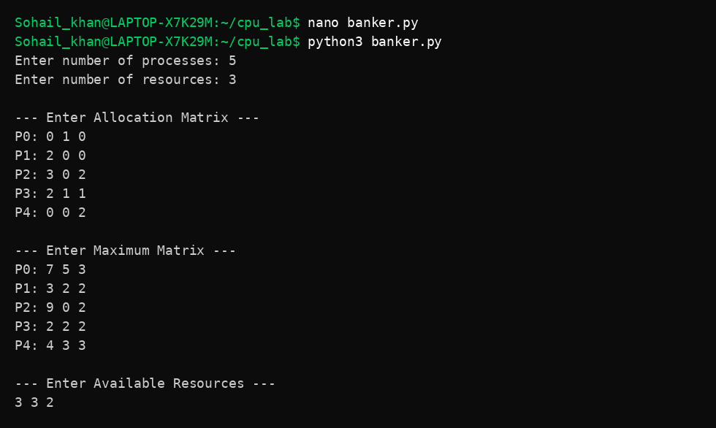

9. Conclusion
In this assignment, Banker’s Algorithm was successfully implemented to ensure safe resource allocation and avoid deadlock in the system. The algorithm determines whether the system is in a safe state by calculating the Need matrix and identifying a safe sequence of process execution.
It was observed that if a safe sequence exists, all processes can complete without causing deadlock. Otherwise, the system enters an unsafe state where deadlock may occur. Thus, Banker’s Algorithm plays an important role in maintaining system stability and efficient resource management in operating systems.

10. References
- Operating System Concepts by Silberschatz
- GeeksforGeeks (CPU Scheduling Algorithms)
- Lecture Notes provided by faculty

